**Streamlining Ticket Assignment for Efficient Support Operations**

**Team Id : NM2025TMID18207**

**Team Leader: S.BHUVANESWARI**

**Team Member1: U.BHAVANASHANKARI**

**Team Member2: S.SATTHISREE**

**Team Member3:S.ROHINI**

**Team Member4:G.KOWSALYA**

**Streamlining Ticket Assignment for Efficient Support Operations**

1. **Purpose:**

This document outlines the processes, tools, and best practices for efficiently assigning support tickets to agents or teams. The goal is to reduce response times, improve workload balance, and increase overall customer satisfaction.

2. **Objectives:**

Minimize ticket handling delays

Ensure fair workload distribution

Route tickets to agents with appropriate expertise

Enhance visibility and accountability of assignments

Automate repetitive steps wherever possible

**3. Scope:**

This procedure applies to all support tickets raised through:

Email

Live chat

Customer portals

Phone call logs converted into tickets

It is relevant for:

Tier 1, Tier 2, and Tier 3 support teams

Support managers and leads

**4. Roles and Responsibilities:**

Role Responsibility

Support Agent Handle tickets assigned to them within SLA

Support Team Lead Monitor ticket queues, redistribute workload if needed

Support Manager Define assignment rules, oversee performance metrics

System Admin Configure automation workflows in the ticketing system

**5. Ticket Assignment Workflow:**

**5.1 Initial Triage:**

Automated categorization based on keywords, product type, customer tier, or SLA priority

Manual review if ticket lacks sufficient information or is misclassified

**5.2 Assignment Logic:**

**Skill**-**based** **routing**: Assign to agents with expertise in the issue’s category

**Load** **balancing**: Distribute tickets based on current workload/queue length

**Priority**-**based** **routing**: High-priority tickets assigned to senior or fast-response agents

5.3 **Escalation:**

Escalate tickets automatically if:

No response within SLA window

Issue complexity exceeds current agent’s level

5.4 **Reassignment:**

Allow team leads to manually reassign tickets to ensure workload balance

**6. Automation Tools and Configuration:**

Examples of automation rules:

Tagging tickets based on product keyword

Auto-assigning tickets from VIP clients to senior support staff

Round-robin assignment to evenly distribute incoming tickets

Integration with chatbots or IVRs for preliminary ticket routing

**Common** **used** **tools**:

Zendesk, Freshdesk, ServiceNow, Jira Service Management, Zoho Desk

**7. Performance Monitoring:**

Track key metrics to measure efficiency:

First Response Time (FRT)

Average Resolution Time (ART)

Ticket Backlog

SLA Compliance Rate

Agent Workload Distribution

Regularly review reports and adjust rules or staffing levels as needed.

**8. Best Practices:**

Keep ticket categories/tags consistent and clear

Update assignment rules quarterly or when new products launch

Train agents on using the ticketing system effectively

Encourage agents to close or merge duplicate tickets promptly

Conduct weekly reviews of queue health

**9. Continuous Improvement:**

Collect agent feedback about assignment accuracy

Use analytics to identify bottlenecks

Refine automation rules based on historical data and changing workload pattern.

**TASK INITIATION**

**Milestone 1: Users**

**Activity 1 : Create Users**

1. Open service now.
2. Click on All  >> search for users
3. Select Users under system security
4. Click on new
5. Fill the following details to create a new user

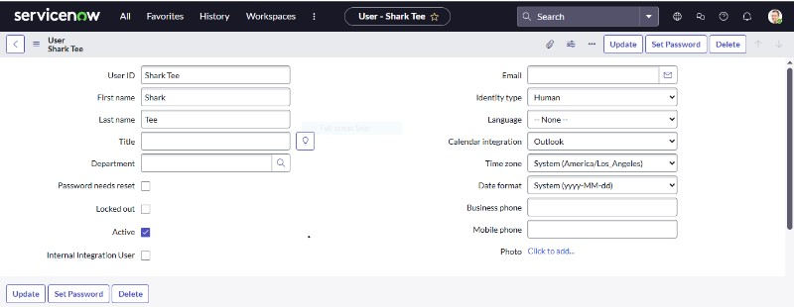  
6. Click on submit  
**Create one more user:**

7. Create another user with the following details  
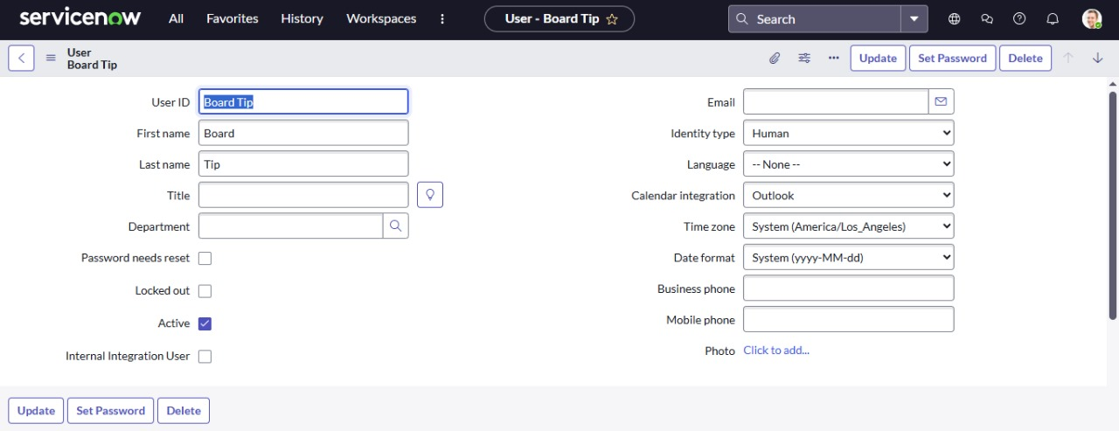

1. Click on submit

**Milestone 2: Groups**

**Activity 1 : Create Groups**

1. Open service now.
2. Click on All  >> search for groups
3. Select groups under system security
4. Click on new
5. Fill the following details to create a new group

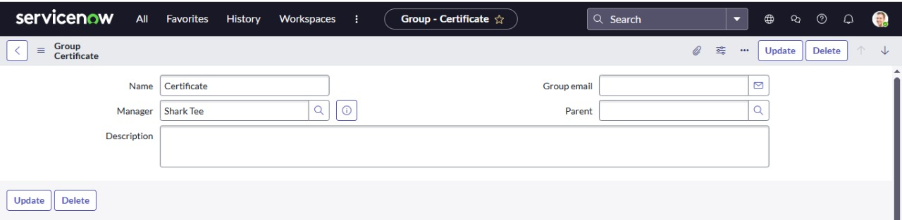

1. Click on submit

**Create one more group:**

1.Create another group with the following details

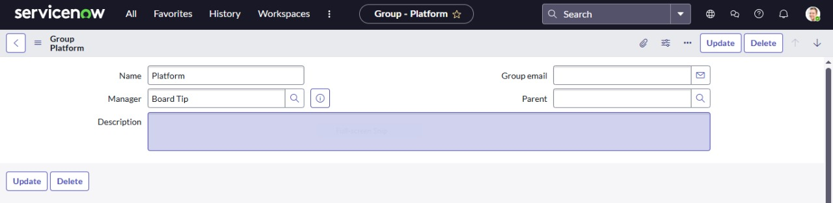

1. Click on submit

**Milestone 3: Rules**

**Activity 1 : Create Rules**

1. Open service now.
2. Click on All  >> search for roles
3. Select roles under system security
4. Click on new
5. Fill the following details to create a new role

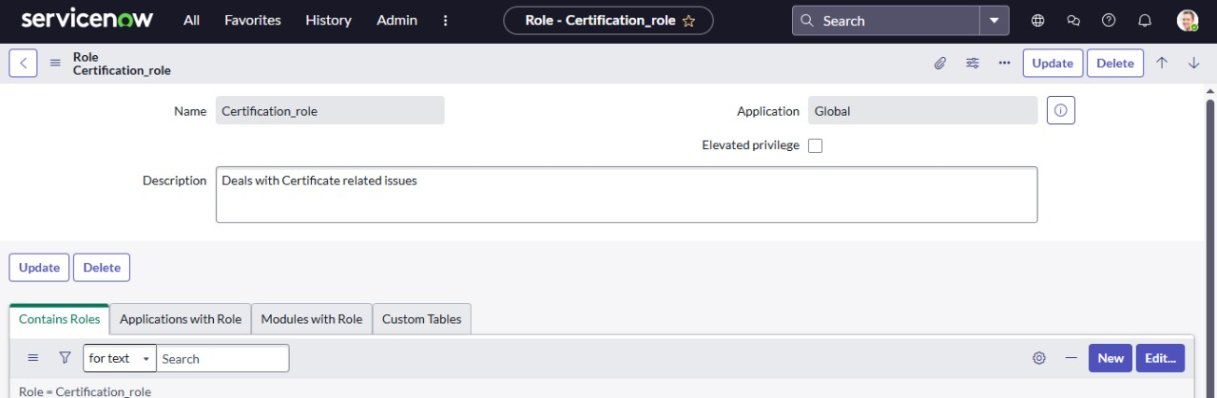  
6. Click on submit

Create one more role:

Create another role with the following details

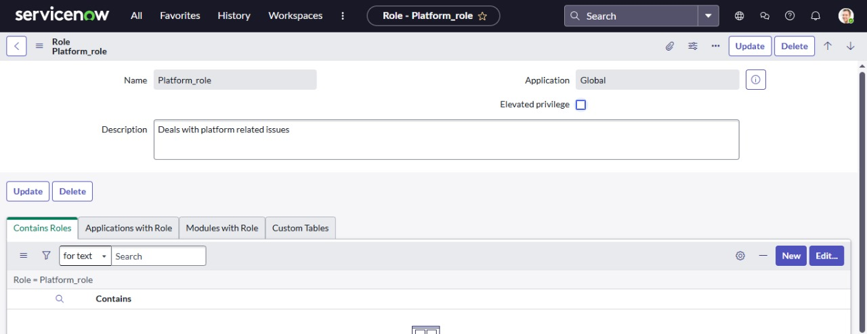

Click on submit

**Milestone 4:Assign Role To Table**

**Activity 1 : Create Assign Role To Table**

1. Open service now.
2. Click on All  >> search for tables
3. Select operations related table
4. Click on the Application Access
5. Click on u_operations_related read operation
6. Click on the profile on top right side
7. Click on elevate role
8. Click on security admin and click on update
9. Under Requires role
10. Double click on insert a new row
11. Give platform role
12. And add certificate role
13. Click on update

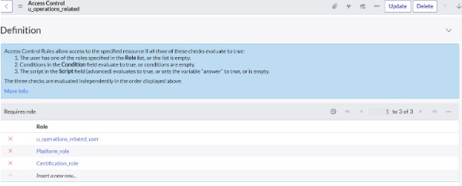

1. Click on u_operations_related write operation
2. Under Requires role
3. Double click on insert a new row
4. Give platform role
5. And add certificate role

**Milestone 5:Create ACL**

**Activity 1 : Create ACL**

1. Open service now.
2. Click on All  >> search for ACL
3. Select Access Control(ACL) under system security
4. Click on new
5. Fill the following details to create a new ACL

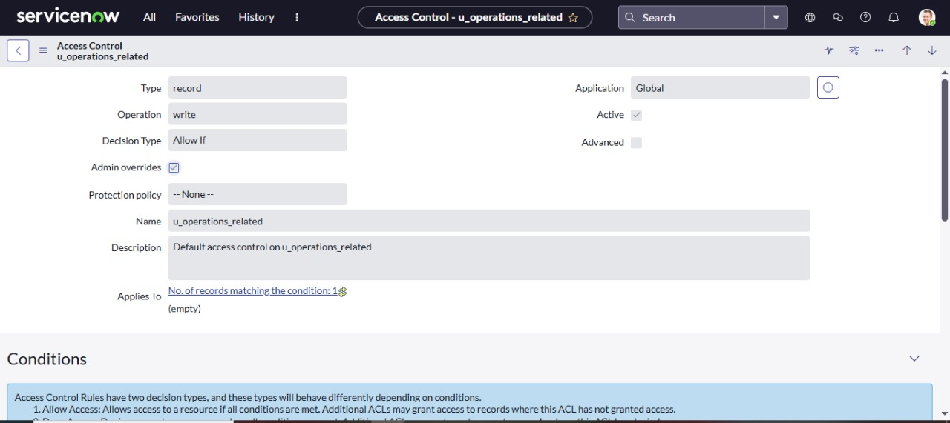

1. Scroll down under requires role
2. Double click on insert a new row
3. Give admin role
4. Click on submit
5. Similarly create 4 acl for the followingfields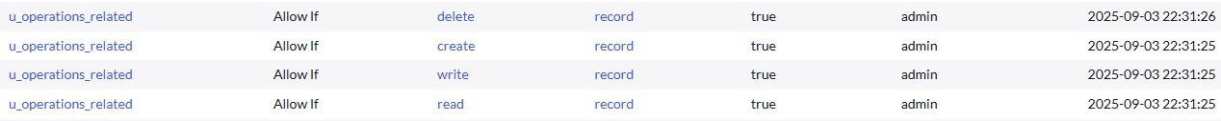

**Milestone 6: Flow**

**Activity 1 :Create a Flow to Assign Operations Ticket To Group**

1. Open service now.
2. Click on All  >> search for Flow Designer
3. Click on Flow Designer under Process Automation.
4. After opening Flow Designer Click on new and select Flow.
5. Under Flow properties Give Flow Name as “ Regarding Certificate”.
6. Application should be Global.
7. Select Run user as “ System user ” from that choice.
8. Click on Submit.

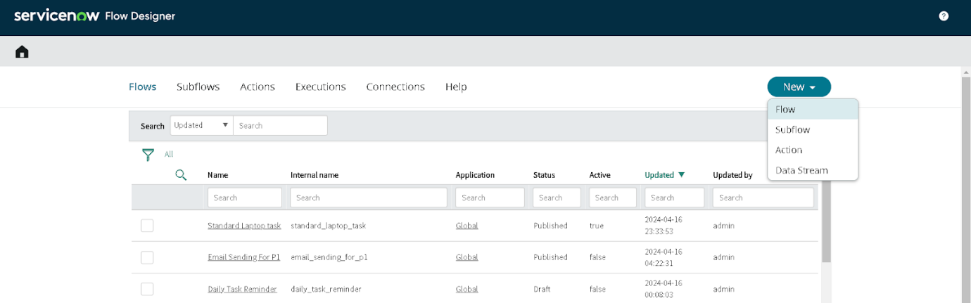

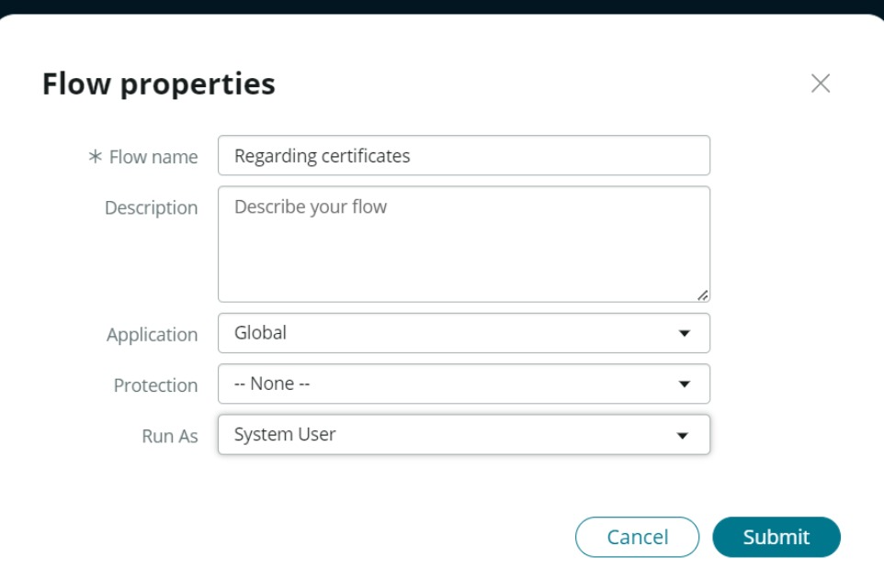

1. Click on Add a trigger
2. Select the trigger in that Search for “create or update a record”  and select that.
3. Give the table name as “ Operations related ”.
4. Give the Condition as

Field: issue

Operator: is

Value: Regarding Certificates

1. After that click on Done

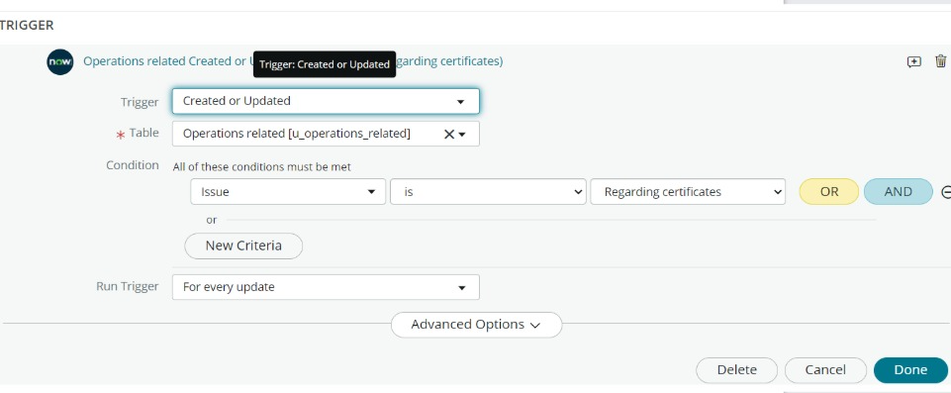

1. Now under Actions.
2. Click on Add an action.
3. Select action in that search for “ Update Record ”.
4. In Record field drag the fields from the data navigation from left side
5. Table will be auto assigned after that
6. Give the field as “ Assigned to group ”
7. Give value as “ Certificates ”
8. Click on Done.
9. Click on Save to save the Flow.
10. Click on Activate.

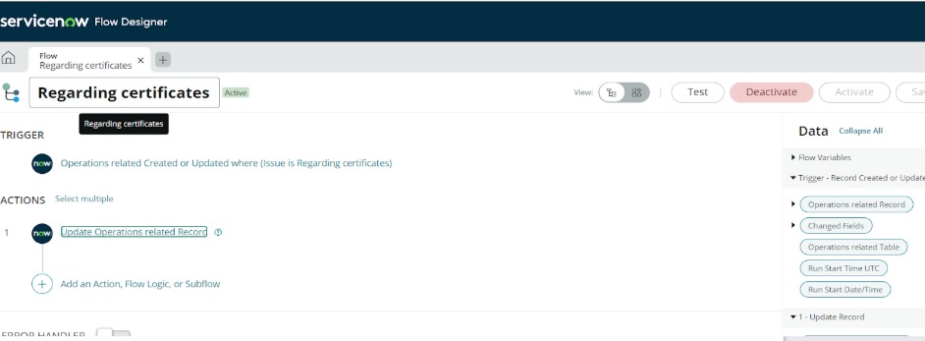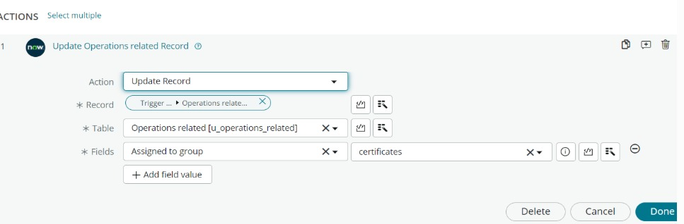

**Activity 2 :Create a Flow To Assign Operations Ticket To Platform Group**

1. Open service now.
2. Click on All  >> search for Flow Designer
3. Click on Flow Designer under Process Automation.
4. After opening Flow Designer Click on new and select Flow.
5. Under Flow properties Give Flow Name as “ Regarding Platform ”.
6. Application should be Global.
7. Select Run user as “ System user ” from that choice.
8. Click on Submit.
9. Click on Add a trigger
10. Select the trigger in that Search for “create or update a record”  and select that.
11. Give the table name as “ Operations related ”.
12. Give the Condition as

Field: issue

Operator: is

Value: Unable to login to platform

1. Click on New Criteria

Field: issue

Operator: is

Value: 404 Error

1. Click on New Criteria

Field: issue

Operator: is

Value: Regarding User expired

1. After that click on Done.
2. Now under Actions.
3. Click on Add an action.
4. Select action in that search for “ Update Record ”.
5. In Record field drag the fields from the data navigation from left side
6. Table will be auto assigned after that
7. Give the field as “ Assigned to group ”.
8. Give value as “ Platform ”.
9. Click on Done.
10. Click on Save to save the Flow.
11. Click on Activate.